
Capstone Project on Flipkart

Project Objective
- The project objective was to collect real-world data; I have taken a global e-commerce brand Flipkart. I have to do some cleaning on the data like renaming columns, handling missing values etc. Then created a recommendation model out of it.

PHASE 1: WEB SCRAPING
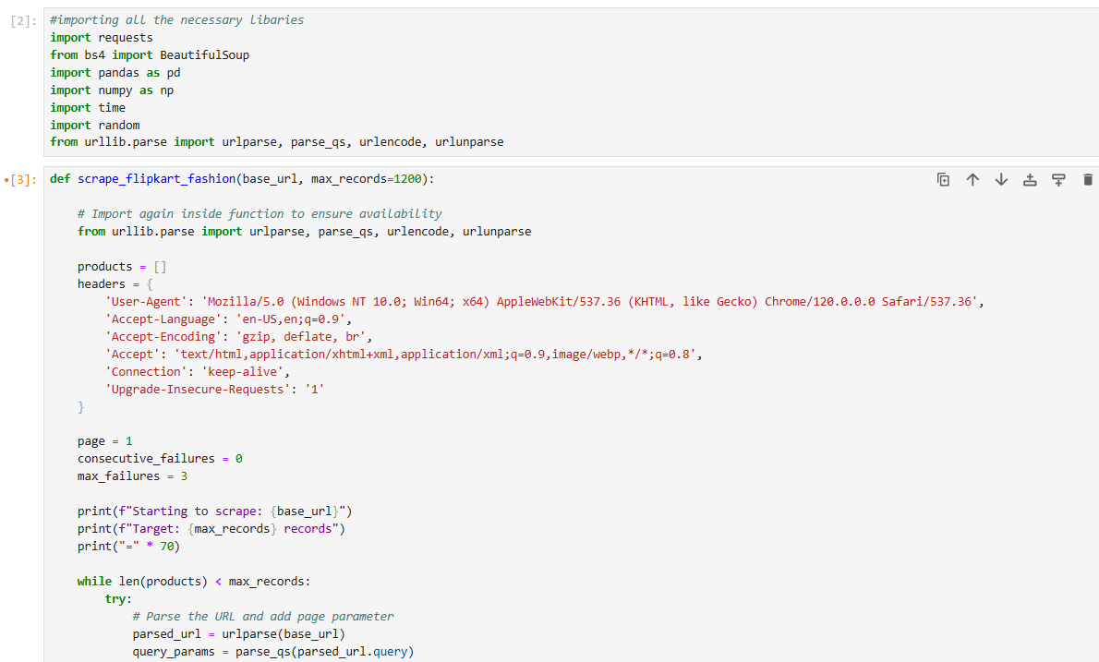
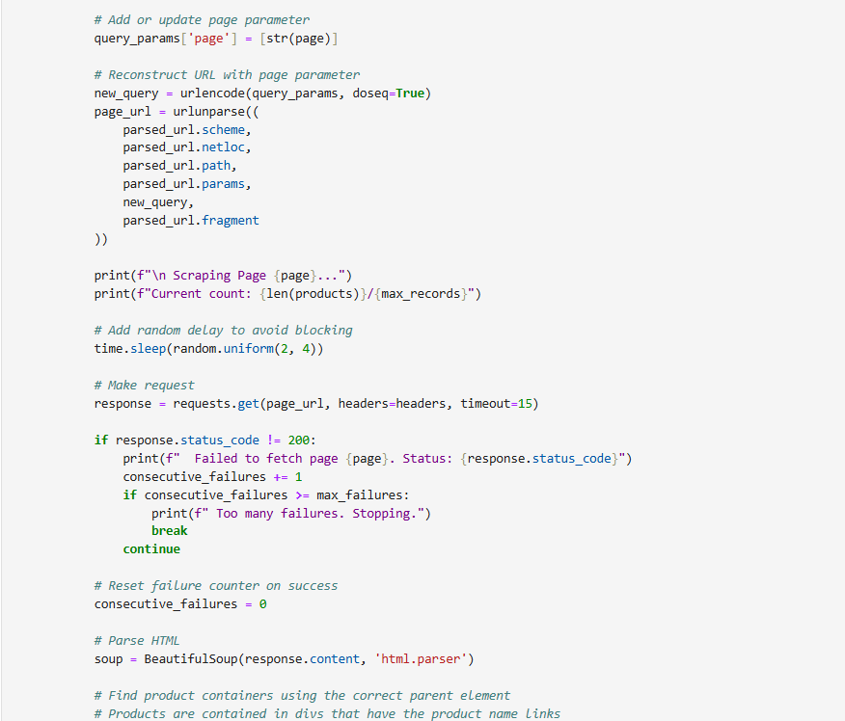
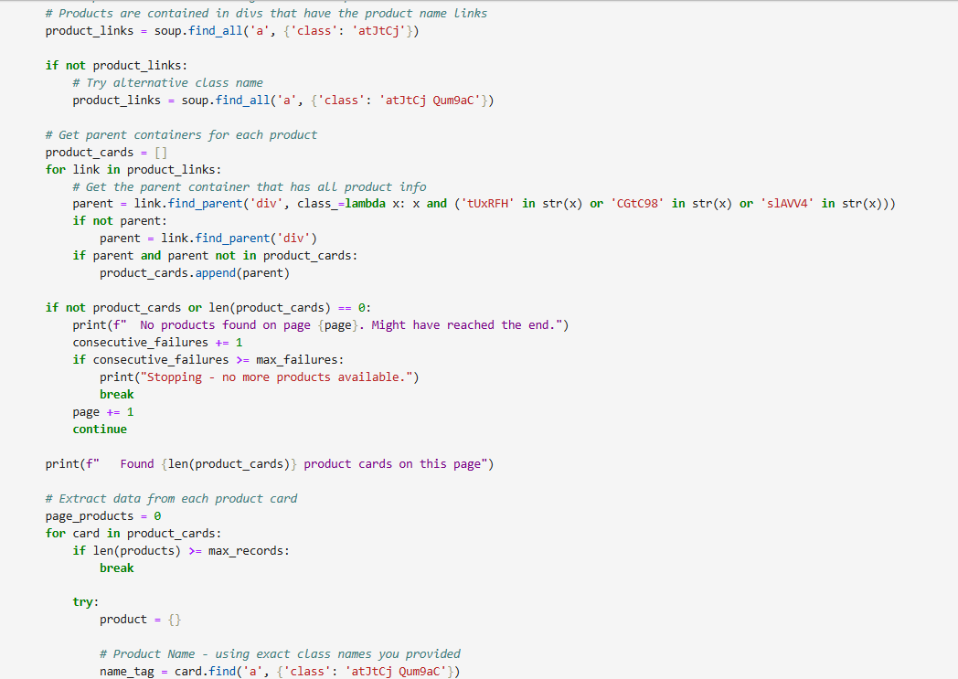
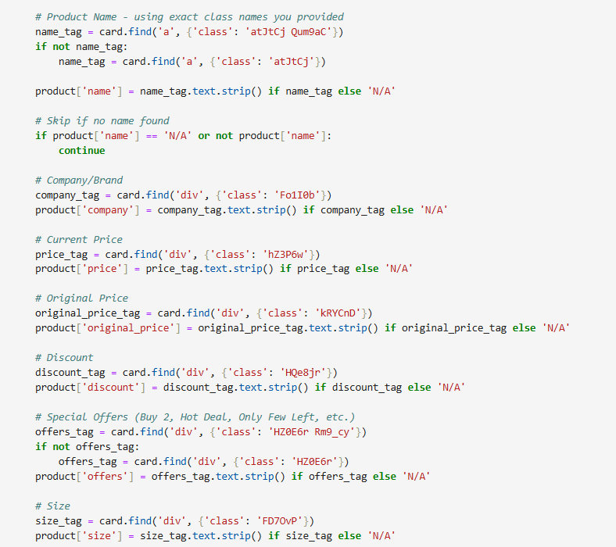
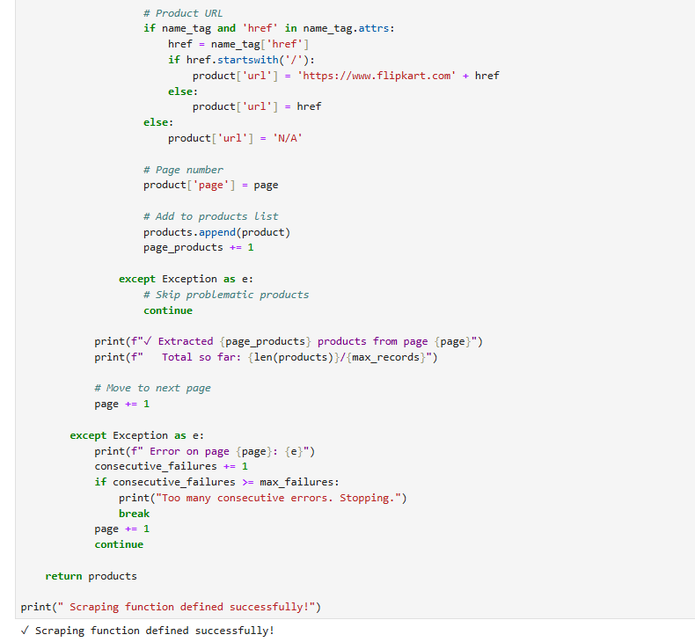
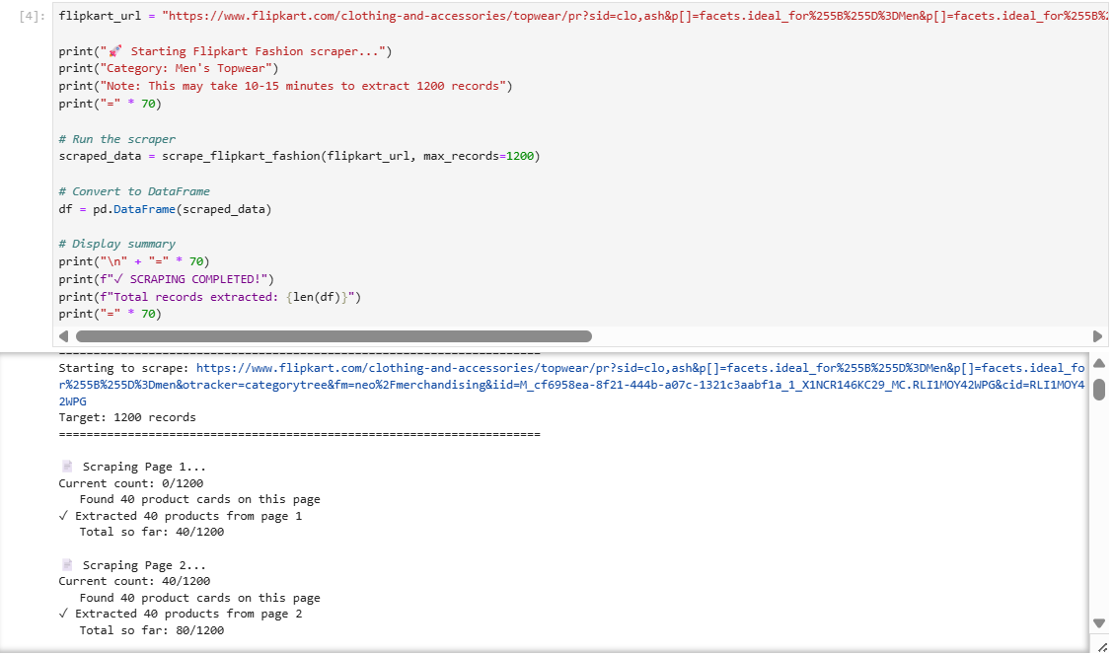
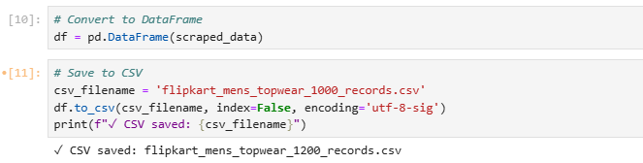

- DATA COLLECTION METHORD
- I have used BeautifulSoup from bs4 and requests, and scraped the section of t-shirt from the Flipkart website and successfully scraped 1000 records.

PHASE 2 : DATA CLEANING & PREPROCESSING 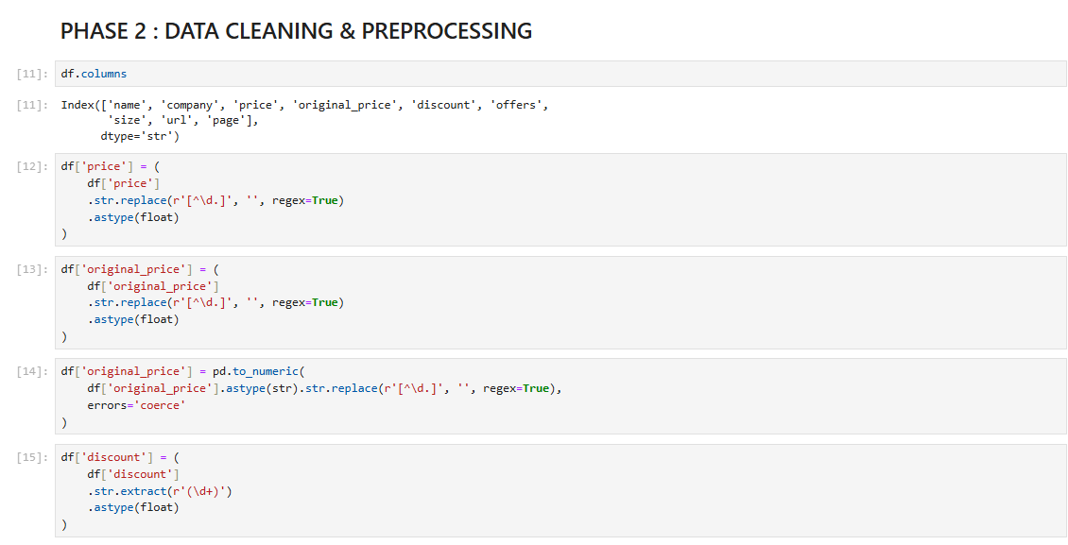
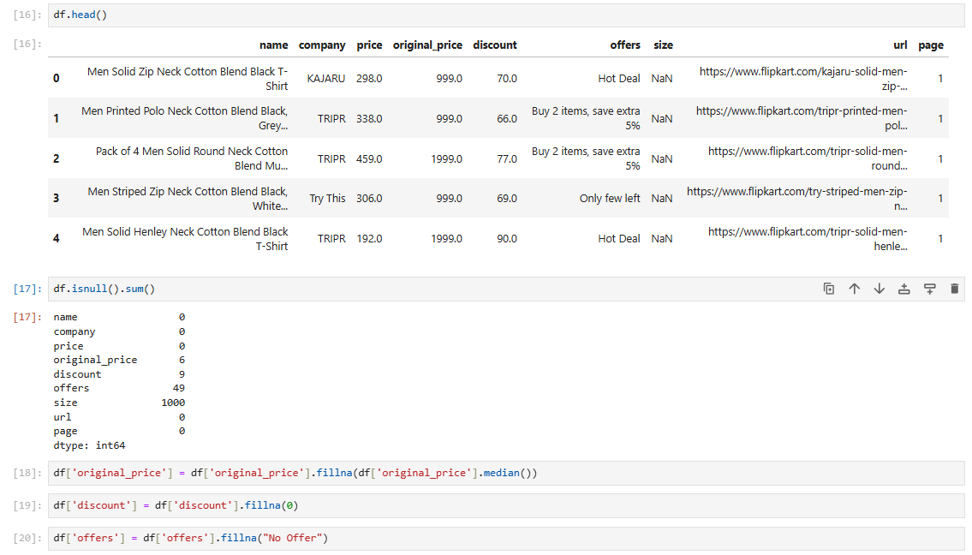

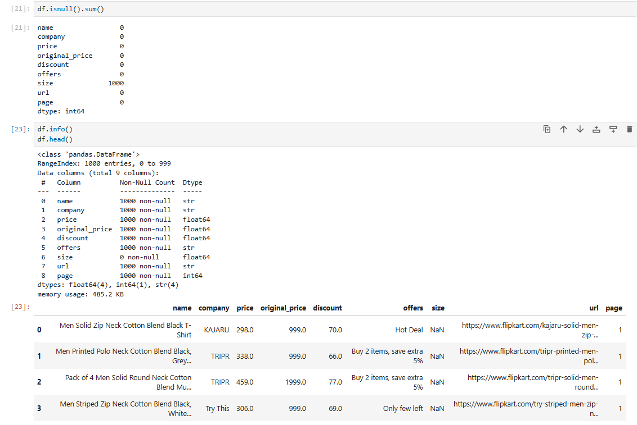

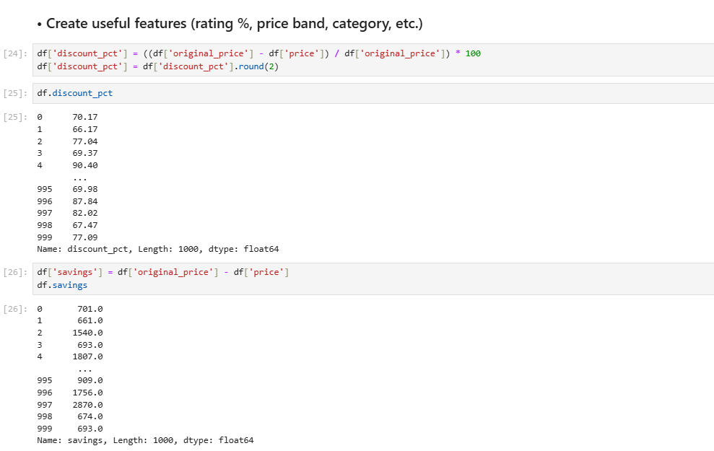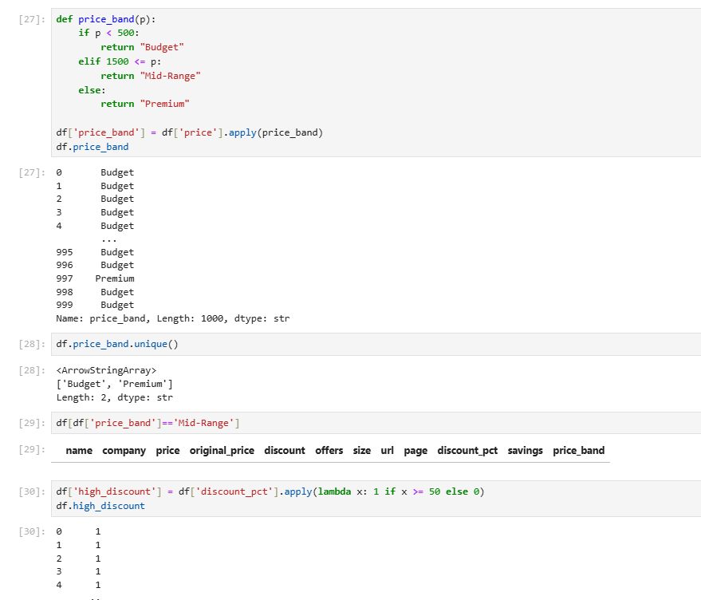
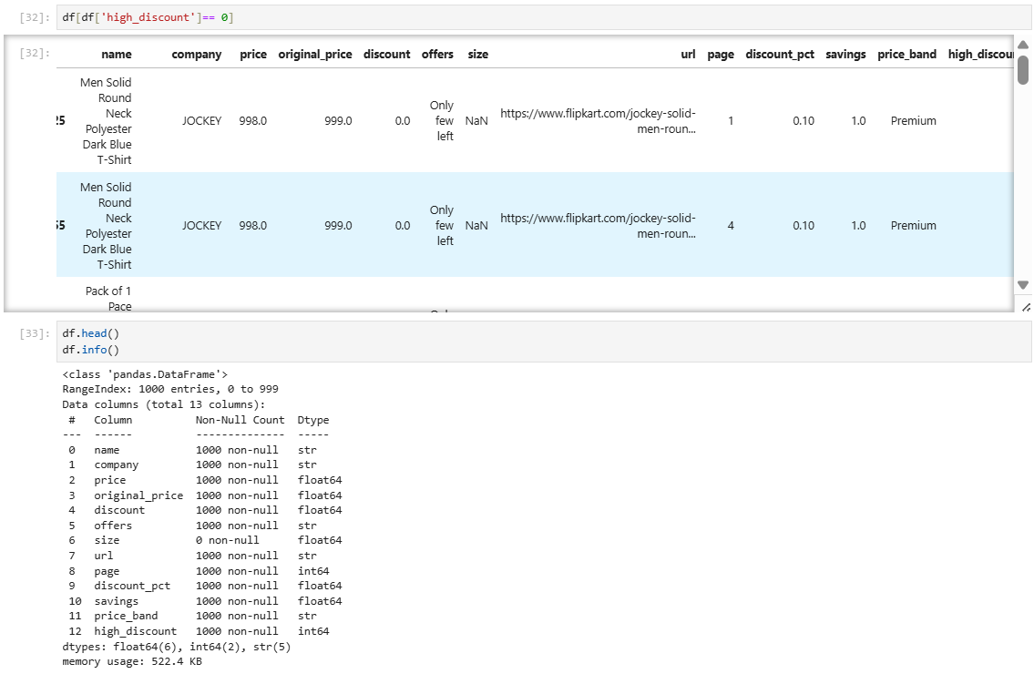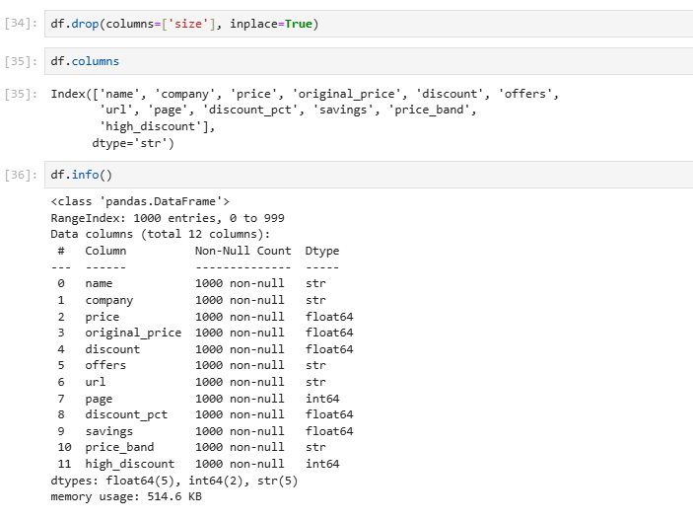

- Cleaning Steps
- I have used pandas and Numpay to clean the data, handling missing values, renaming columns and made it ready for analysis.

PHASE 3 : EXPLORATORY DATA ANALYSIS (EDA)

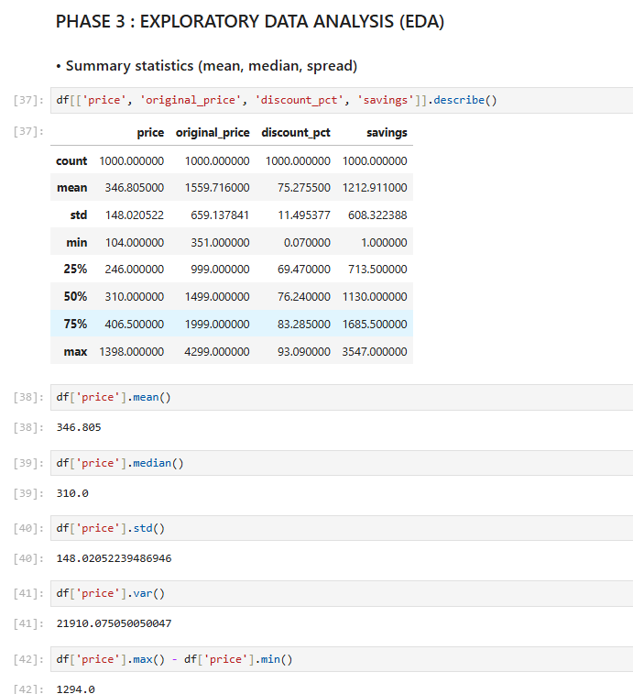
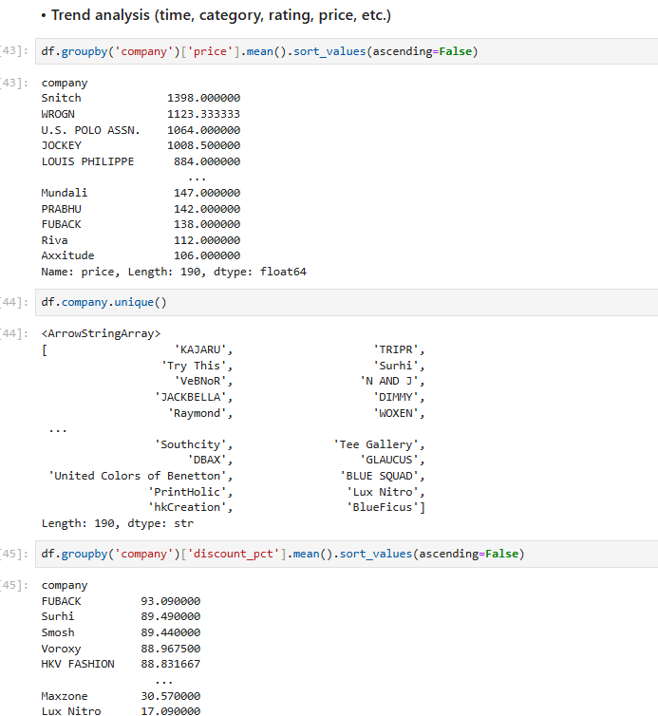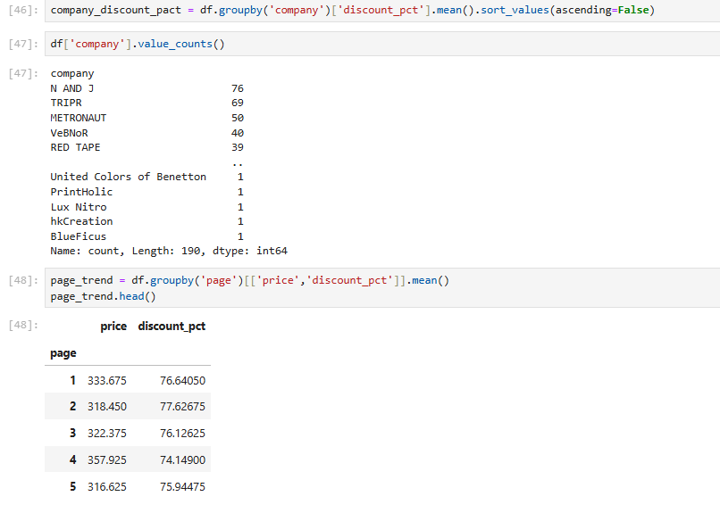

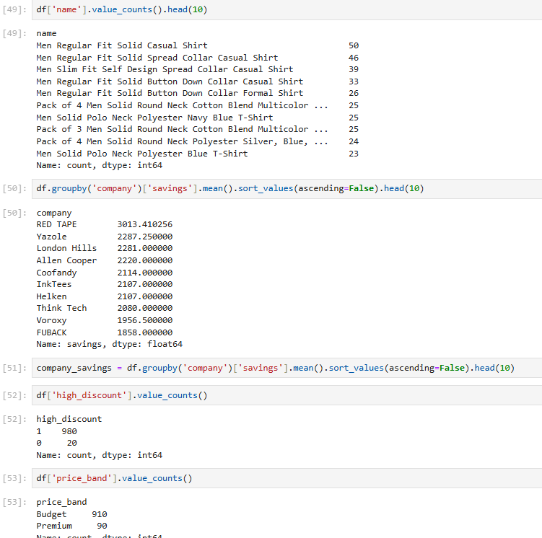
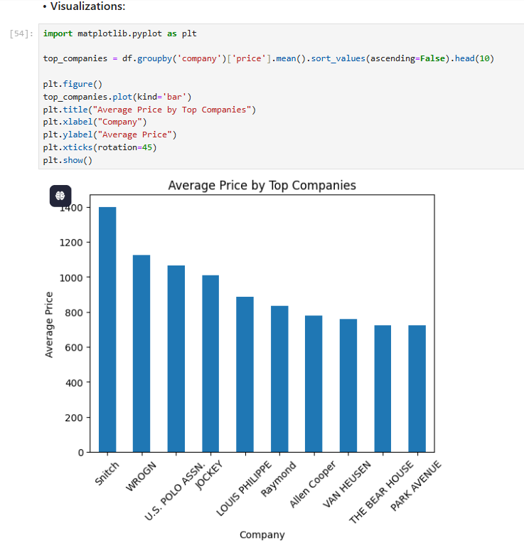

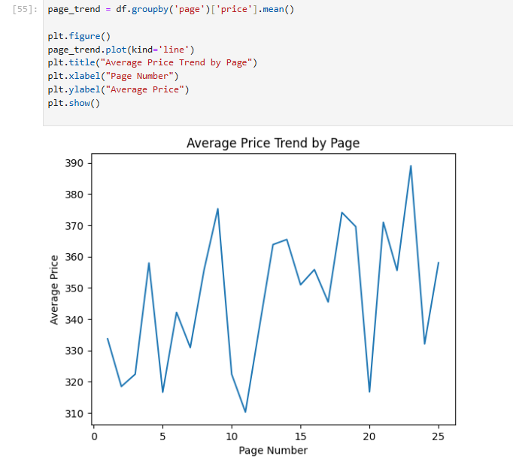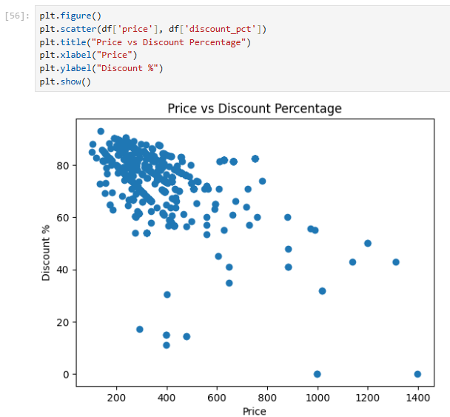
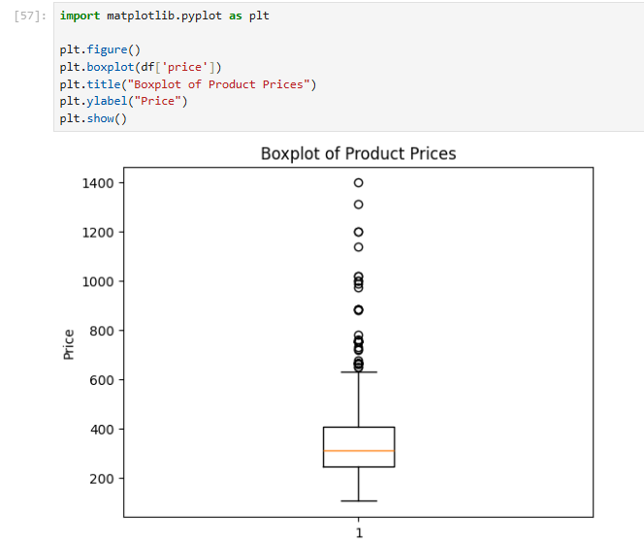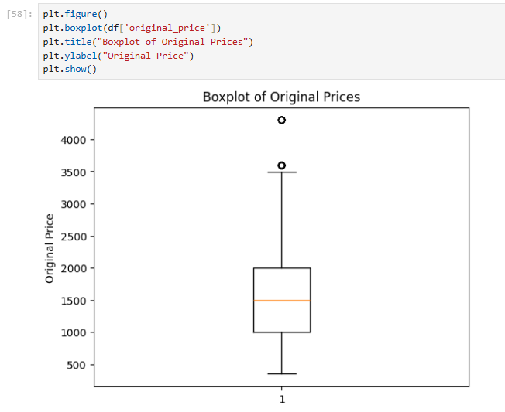
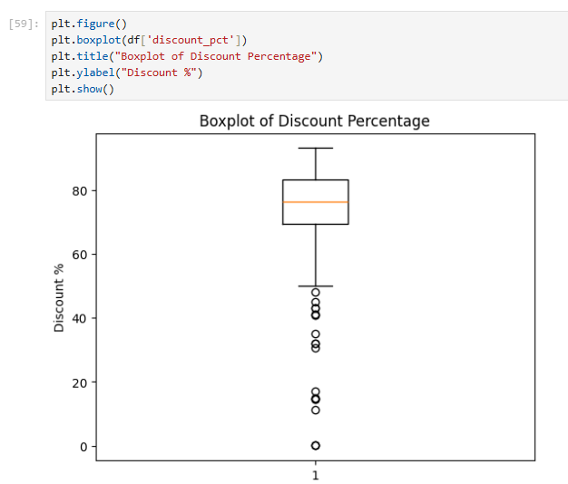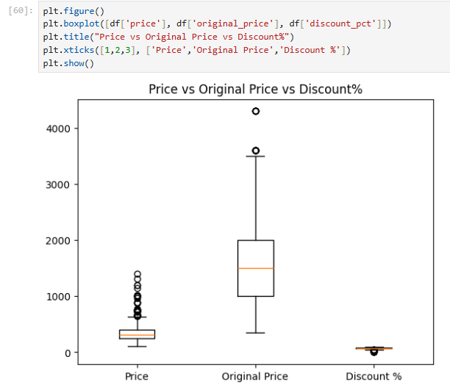
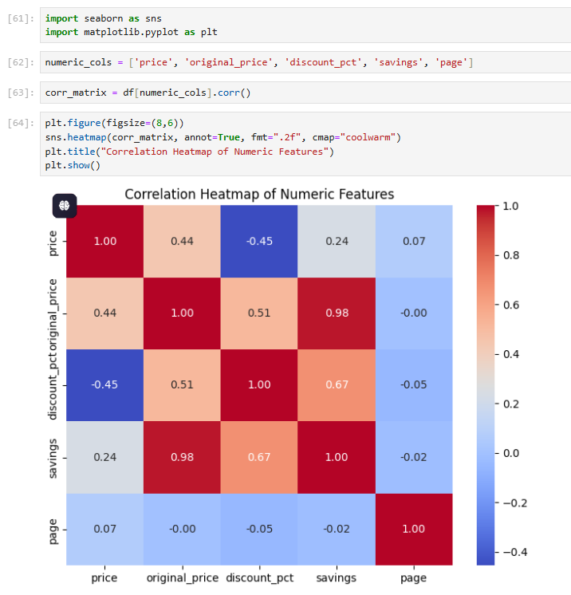
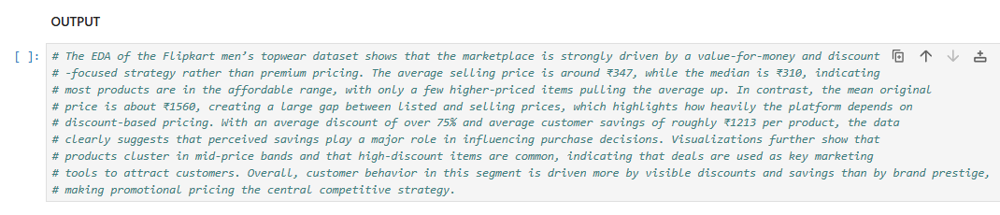
- Output
- The EDA of the Flipkart men’s topwear dataset shows that the marketplace is strongly driven by a value-for-money and discount-focused strategy rather than premium pricing. The average selling price is around ₹347, while the median is ₹310, indicating most products are in the affordable range, with only a few higher-priced items pulling the average up. In contrast, the mean original price is about ₹1560, creating a large gap between listed and selling prices, which highlights how heavily the platform depends on discount-based pricing. With an average discount of over 75% and average customer savings of roughly ₹1213 per product, the data clearly suggests that perceived savings play a major role in influencing purchase decisions. Visualizations further show that products cluster in mid-price bands and that high-discount items are common, indicating that deals are used as key marketing tools to attract customers. Overall, customer behavior in this segment is driven more by visible discounts and savings than by brand prestige, making promotional pricing the central competitive strategy.

PHASE 4 : MACHINE LEARNING MODEL

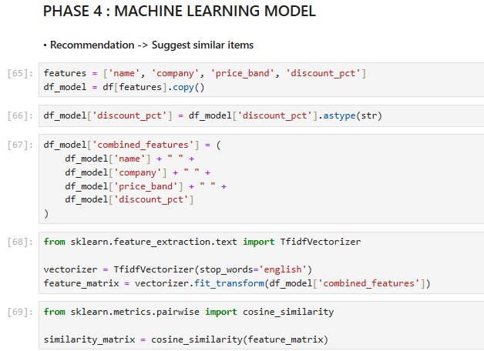
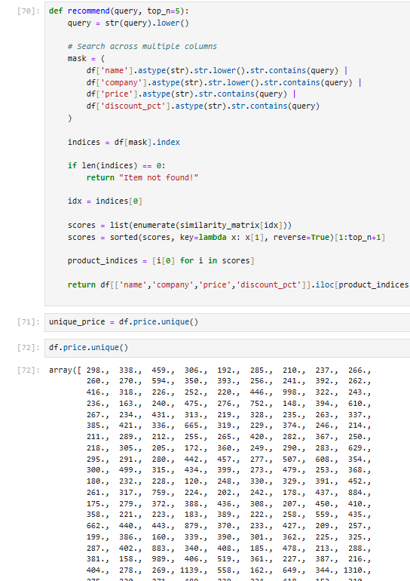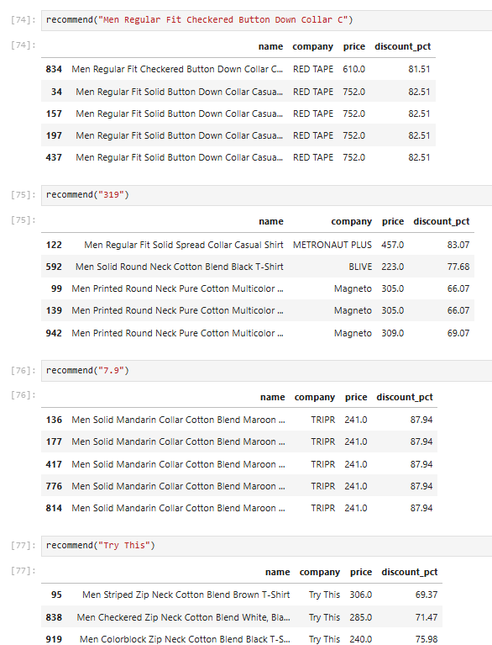
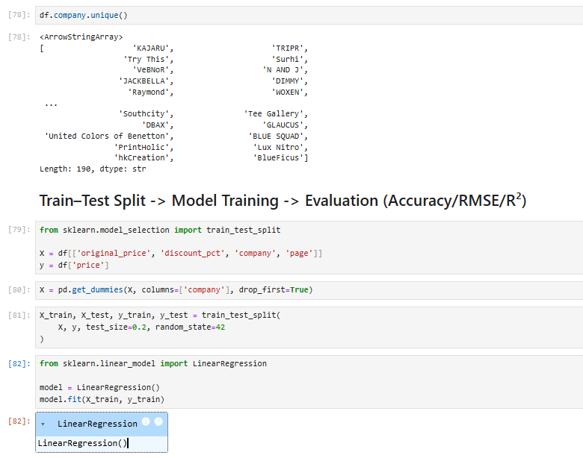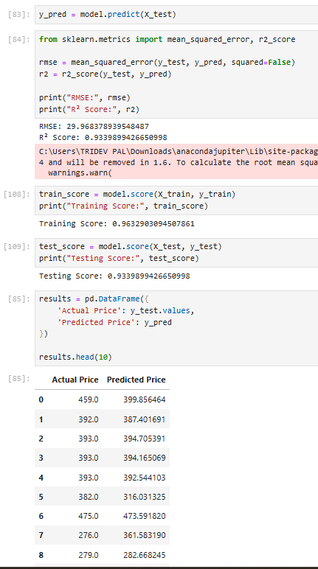

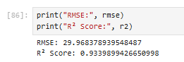
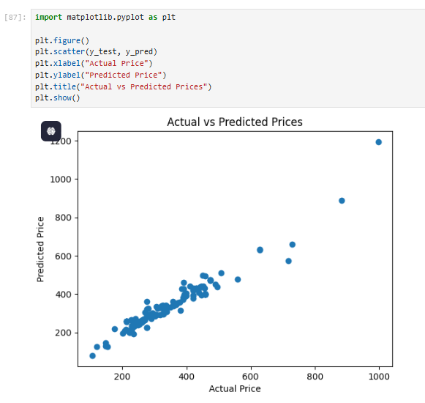
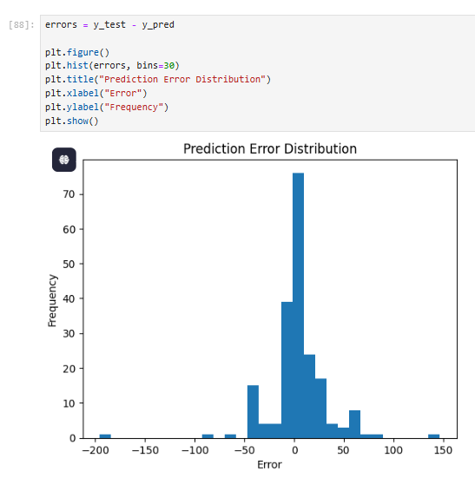
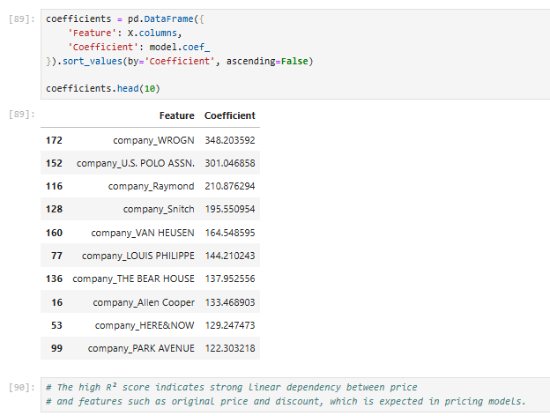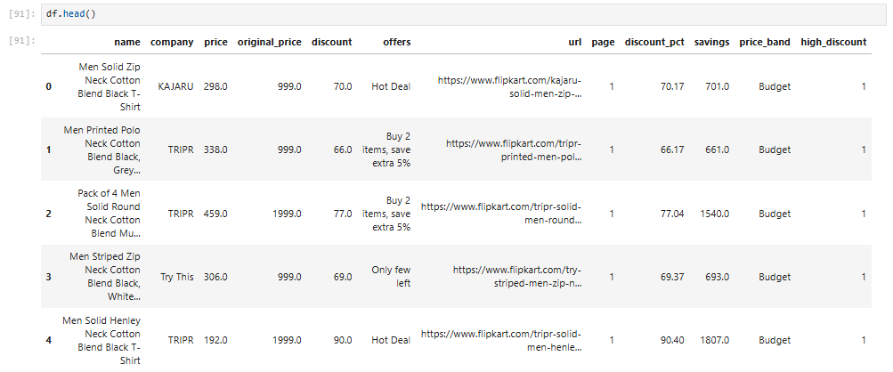
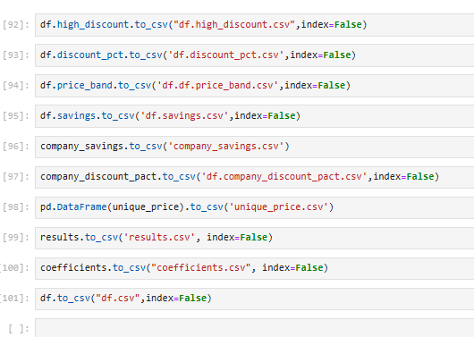
- Model Performance
- My model is performing well. It has a r^2 of 0.9339 and a RMSE of 29.9683 for Training score it is 0.9632 and for Testing score it is 0.93398.
The higher the r^2 indicates the stronger linear dependency between price and feature such as original price and discount which is expected in a price predicting model.

PHASE 5 : INTERACTIVE DASHBOARD
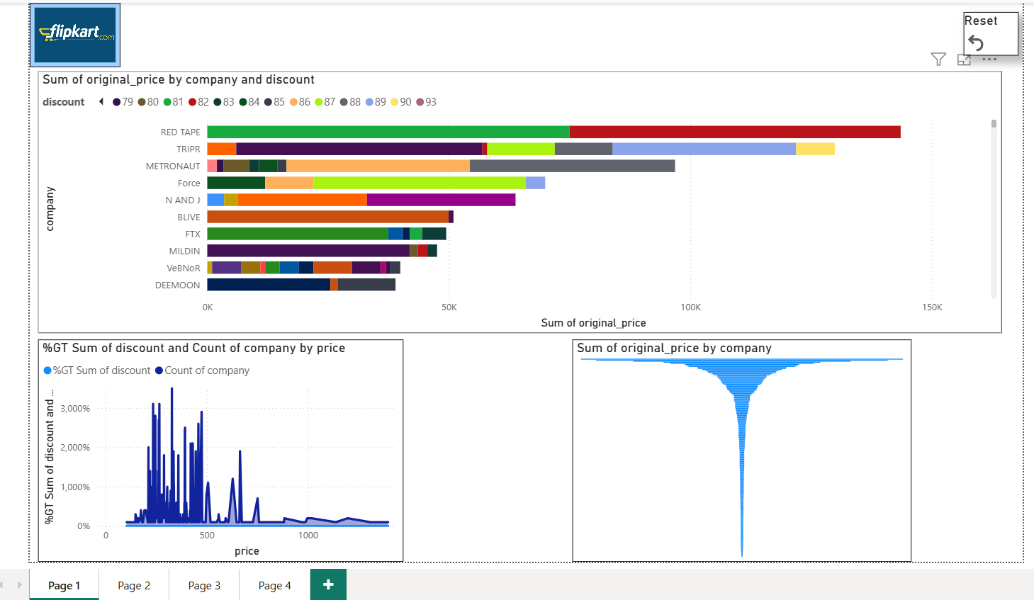

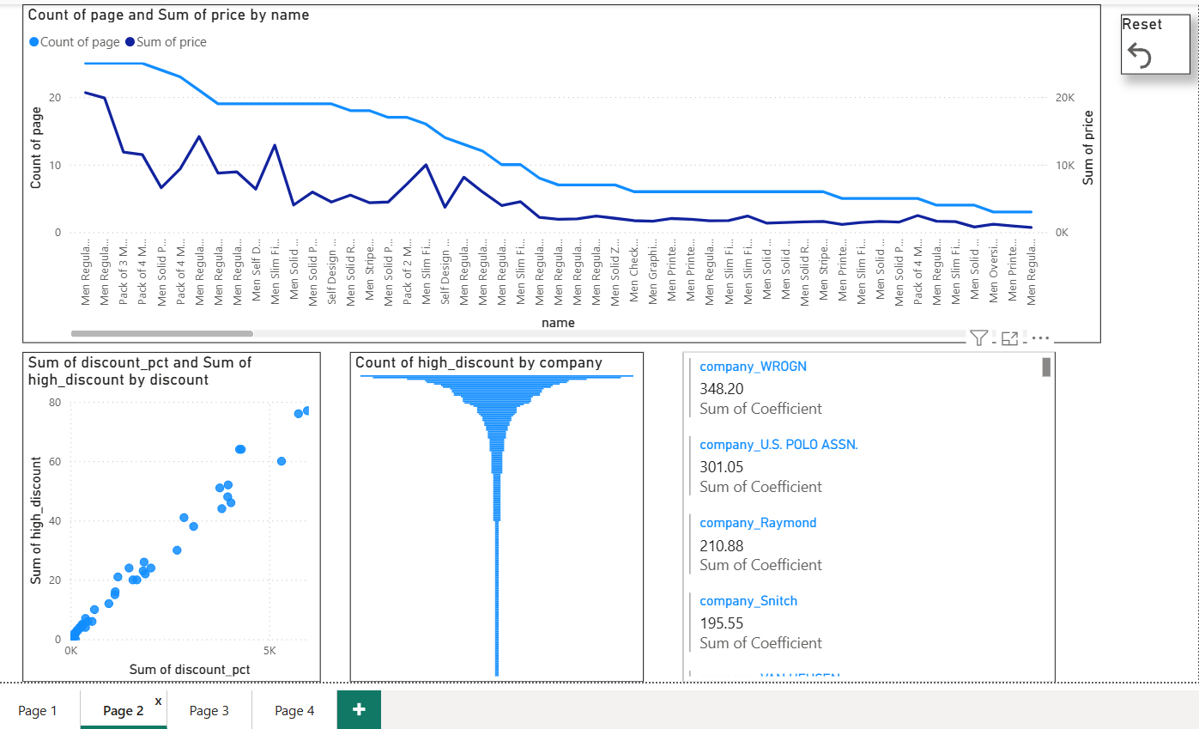
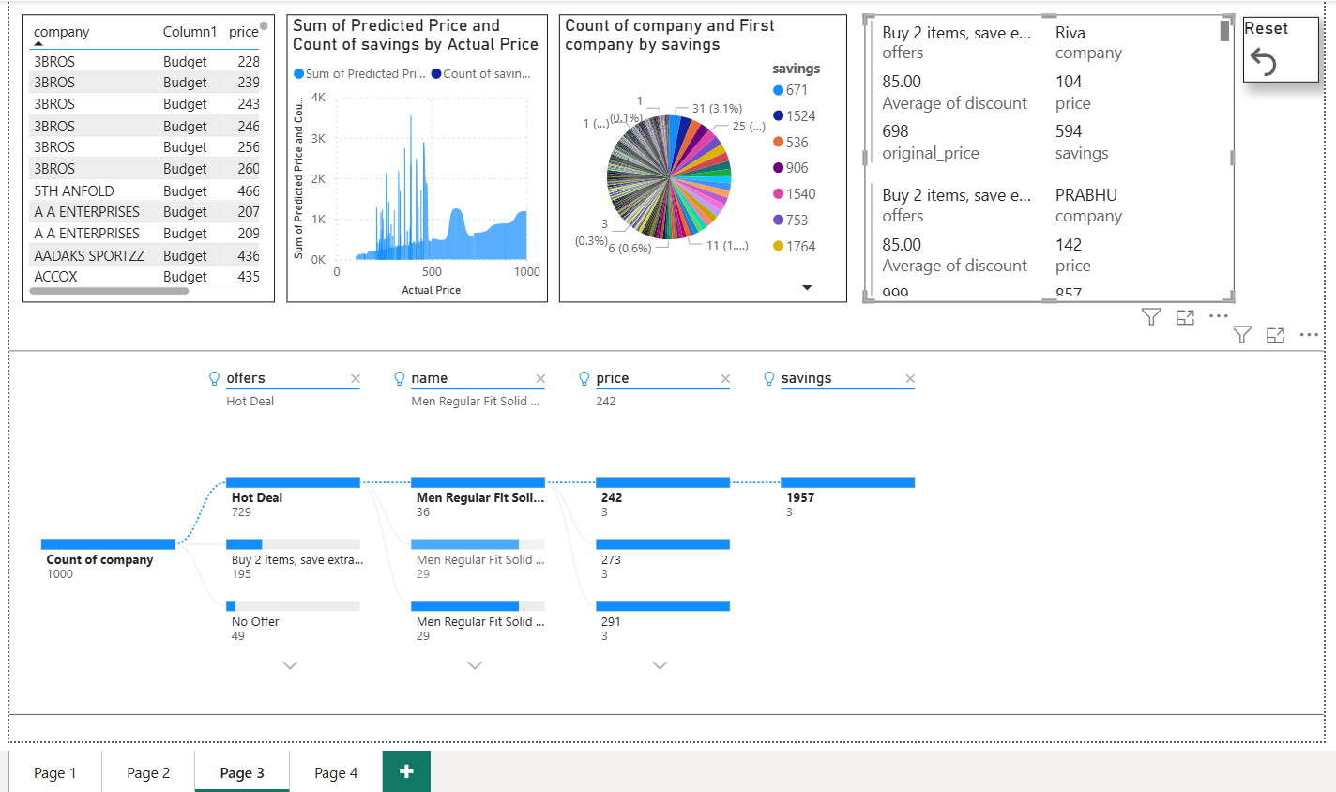

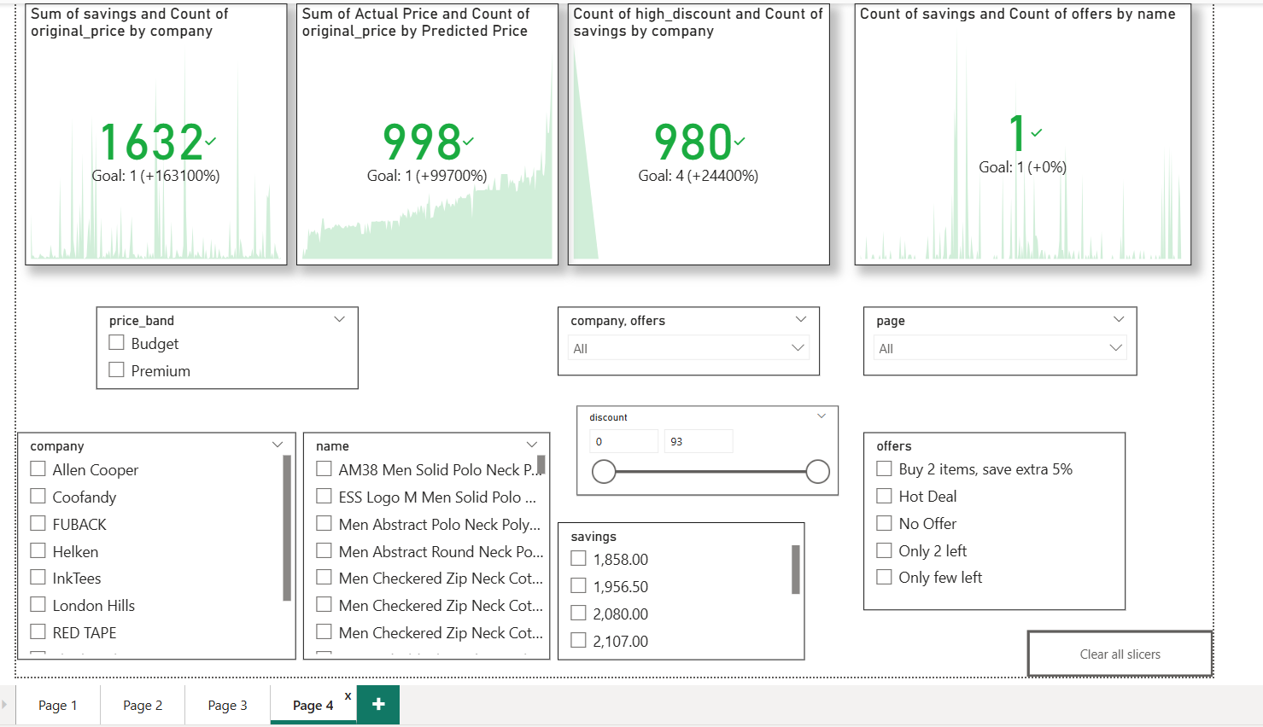

- Key Business Insight
- Customer purchase behaviour in men’s fashion is driven by discount dept, midrange pricing and promotional offers rather than brand premium position.

- Recommendations
- Our platform should flow a promotional driven, value focused strategy where revenue comes from discount structure ,midrange pricing and mult offers building rather than premium position.

